# Installation Guide

## Connecting a Windows® Azure™ Customer Portal to Microsoft Dynamics® CRM

Use this guide to learn about the steps required to install an Azure-based portal which is connected to Microsoft Dynamics® CRM (the Microsoft Dynamics CRM solution can be running Online or On-Premise).

***Important information:*** *Please review the steps in this installation guide before beginning your deployment process. This setup process is* ***technical*** *and assumes a level of proficiency with managing Microsoft Dynamics CRM customization imports, ASP.NET and Windows Server Internet Information Server (IIS). If you don’t have any experience with Visual Studio or setting up ASP.NET web sites then you will find the steps in this guide to be complex. You are urged to engage with an appropriately experienced technical resource to deploy your portal. However, once your portal is deployed then a business representative can configure the majority of the content and functionality.*

## Pre-Requisite Setup Steps

To complete the installation of the Customer Portal solution for Microsoft Dynamics CRM you will need the following technology pieces in place:

### Microsoft Dynamics CRM

* **Microsoft Dynamics CRM Online:**
  + If you are signing up for Microsoft Dynamics CRM Online then you will need a Windows Live™ ID (hereafter referred to as WLID) for setup and billing purposes.
  + For more details on setting up your Microsoft Dynamics CRM Online account, go to <http://crm.dynamics.com> where you can sign up for a free 30-day trial account [here](http://crm.dynamics.com/en-us/trial-overview.aspx).
  + If you need to set up a WLID then go to <https://login.live.com/>.
  + You will need a second WLID which will be used to call the required Microsoft Dynamics CRM web services from the portal. We recommend that you do **not** use the same WLID that is used for billing in Microsoft Dynamics CRM or Windows Azure. This second WLID will also need a Device-ID and Device-Password for the authentication to Microsoft Dynamics CRM Online. Each connection to the Windows Live service requires a user-defined Device ID which can be any string from 12-22 characters. This device ID will be registered the first time an authentication is run (for example, running WebsiteCopy.exe with this device ID for the first time will register that device ID) and will be required for all subsequent authentications with that WLID. The Device-Password must also be 12-22 characters. Once you have decided on your Device ID and Password, make a note of them; you will need this ID and Password for every connection you make to Microsoft Dynamics CRM Online with this WLID.  
    **Note**: You won’t select the Device ID and Password when you set up the WLID account but you will need to specify the Device ID and Password in the connectionString in the web.config file of the portal. An example of this connection string is shown in Step 10 of this guide.
  + Once you have set up this WLID, you will need to set up a Microsoft Dynamics CRM user account that uses this WLID. Ensure that this Microsoft Dynamics CRM user account is set up with a minimum set of permissions to allow access to only the required portal functionality. It is recommended that you use the **System Administrator** pre-defined security role during the setup process, and then later restrict the user to only the privileges required by the nature of your portal’s functionality.
* **Microsoft Dynamics CRM On-Premise or Partner-Hosted:**
  + You will need to set up a Microsoft Dynamics CRM user account that will be used to call the required Microsoft Dynamics CRM web services from the portal. Ensure that this Microsoft Dynamics CRM user account is set up with a minimum set of permissions to allow access to only the required portal functionality. It is recommended that you use the **System Administrator** pre-defined security role during the setup process (**Settings 🡪 Administration 🡪 Security Roles**), and then later restrict the user to only the privileges required by the nature of your portal’s functionality. 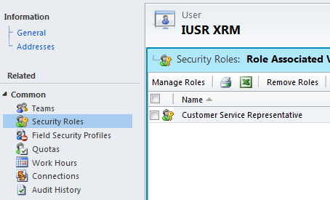

### Windows Azure

* The portal requires a Windows Azure Hosted Service; it does not use any worker roles or any of the SQL Azure or AppFabric services.
* You will need to use a Windows Live™ ID (hereafter referred to as WLID) for billing purposes with Windows Azure. If you are a Microsoft Dynamics CRM Online customer it is suggested that you use the same WLID that you use for Microsoft Dynamics CRM Online billing.
* For more details on signing up for Windows Azure and the various pricing packages available to you, go to <http://www.microsoft.com/windowsazure/>.
* For more details on Windows Azure development, see the [Developer Center](http://msdn.microsoft.com/en-us/windowsazure/default).

### Other Requirements

* To deploy your portal to Windows Azure, you need a computer with an internet connection and you must install the following software:
  + Microsoft Visual Studio® 2010. This is required on any computer that will be used to edit the settings and tailor your portal site(s).
  + [Windows Azure SDK and Windows Azure Tools for Microsoft Visual Studio (November 2010)](http://www.microsoft.com/downloads/en/details.aspx?FamilyID=7a1089b6-4050-4307-86c4-9dadaa5ed018&displaylang=en) which extends Visual Studio 2010 to enable the debugging, running, and publishing of your portal site(s) on Windows Azure.
  + Microsoft Dynamics CRM SDK which can be downloaded from [here](http://www.microsoft.com/downloads/en/details.aspx?FamilyID=420f0f05-c226-4194-b7e1-f23ceaa83b69).

**Additional note: *If you have already deployed the Partner Portal solution for Microsoft Dynamics CRM then you can skip steps 1 and 2 below.***

## Deployment Steps

1. Import the customizations file provided:
   1. Ensure pop-up blocker does not cause errors to occur during the import process. In Internet Explorer either turn off Pop-up Blocker (go to **Tools 🡪 Pop-up Blocker 🡪 Turn Off Pop-up Blocker**) or add your CRM site to allowed sites (go to **Tools 🡪 Pop-up Blocker 🡪 Pop-up Blocker Settings**).
   2. Go to **Settings** 🡪 **Solutions** 🡪 **Import:** 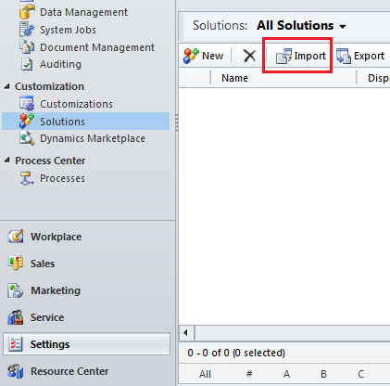
   3. Select the solution package (MicrosoftXrmCustomerPortal.zip located in the root directory of your Customer Portal for Microsoft Dynamics CRM setup package) and review package details: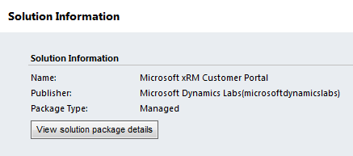
   4. Select the check box to enable post import actions: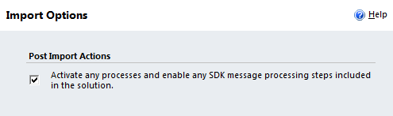
   5. Wait for the import process to complete. A new entry for the imported solution is displayed in the Solutions list: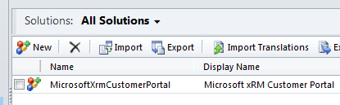
   6. While still under **Settings** 🡪 **Solutions**, click **Publish All Customizations:**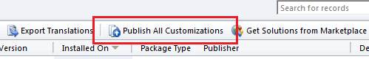
   7. Once the import process is completed, refresh your browser. The navigation pane of Microsoft Dynamics CRM includes the Content Management tab.  
      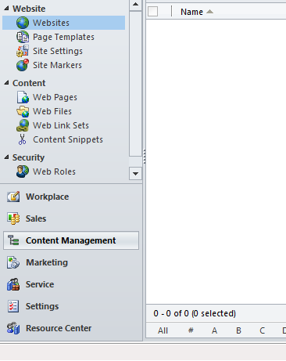
2. Update the portal sign-up invitation e-mail message:
   1. In Microsoft Dynamics CRM go into **Settings** 🡪 **Processes**
   2. Edit the process named **MSA-Customer Portal: Customer portal sign-up invitation:**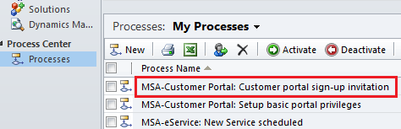
      1. If the process is already activated, click the **Deactivate** button: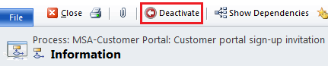
      2. Edit the portal invitation e-mail message that is sent to customers by clicking the **Set Properties** button: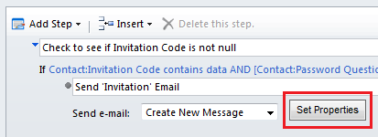
      3. Edit the URL for your web portal. This is used to validate an invited web portal customer based on a secret question and answer that is stored in Microsoft Dynamics CRM: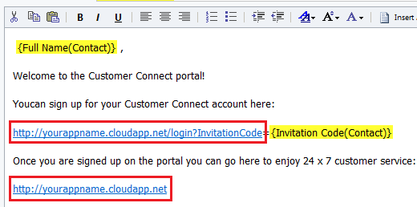 Leave the login?InvitationCode={Invitation Code(Contact)} text as is.
      4. Save and close the email properties and activate the process.
   3. Repeat the previous steps to customize the e-mail messages for the processes named **MSA-eService: New Service scheduled**, **MSA-Event Management Attendee Post-Event Process**, and **MSA-Event Management: Send Acknowledgement Email**.
3. The final step in the preparations is to upload the initial website content into Microsoft Dynamics CRM using the websitecopy utility. The Microsoft Dynamics CRM [SDK](http://www.microsoft.com/downloads/en/details.aspx?FamilyID=420f0f05-c226-4194-b7e1-f23ceaa83b69) has full details about this utility. You need to run this utility to upload the content in customerportal.xml into CRM. The utility can be run from the command line; will launch a wizard GUI when launched without parameters. It is recommended that you use the second WLID account created in a previous step of this guide and not the account that is used for billing in Microsoft Dynamics CRM or Windows Azure. The following example demonstrates how to upload to an online deployment:

> WebsiteCopy.exe /sourceFile:customerportal.xml /targetConnectionString:"Url=https://crm-organization-name.crm.dynamics.com; UserName=your-wlid@hotmail.com; Password=your-wlid-pwd; DeviceID=your-device-name; DevicePassword=your-device-pwd" /targetWebsiteName:"Customer Portal"

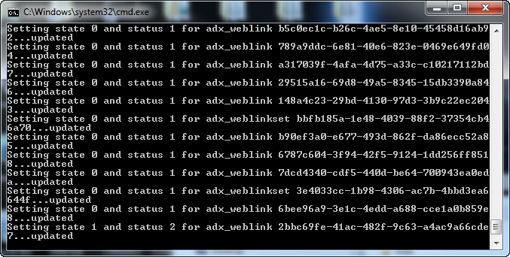

Alternatively, to use the GUI, launch WebsiteCopy.exe follow the wizard steps:

* 1. Select **XML file** as the source of the website data:

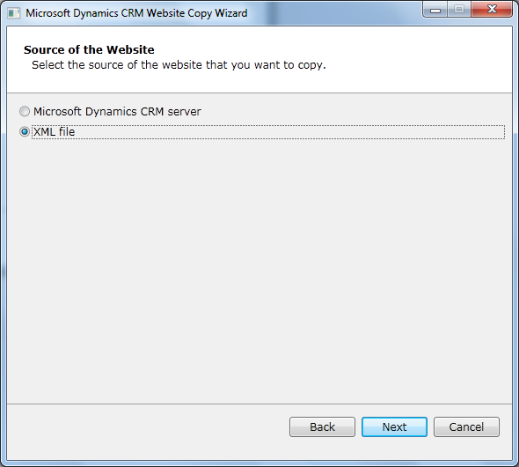

* 1. Select CustomerPortal.xml, included with the portal distribution:

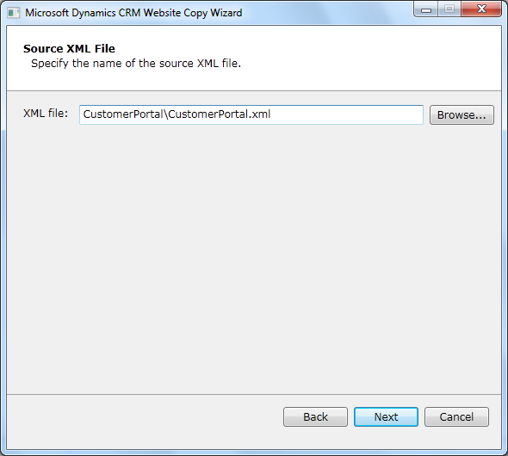

* 1. Select **Customer Portal** as the source website:

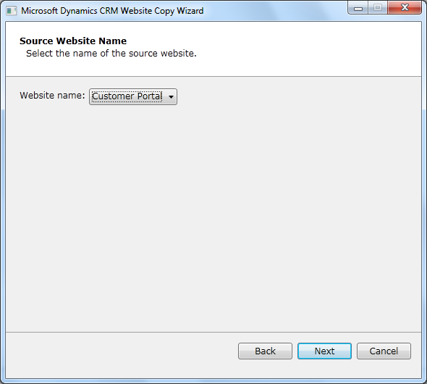

* 1. Select **Microsoft Dynamics CRM Server** as the destination, and enter your connection information:

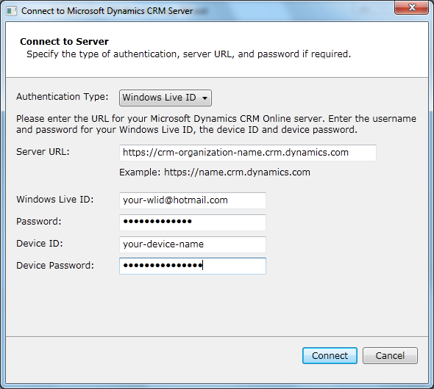

* 1. Select your destination organization, and then provide **Customer Portal** as the name for the new website:

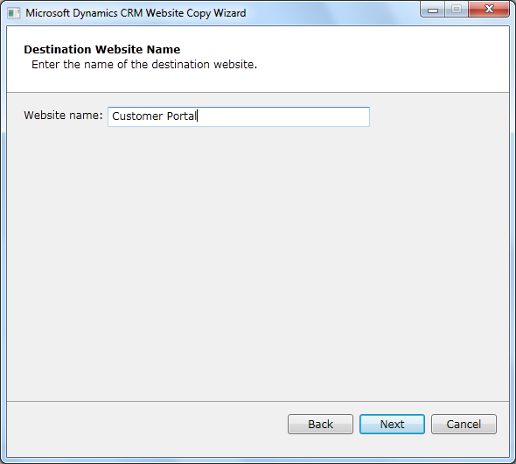

* 1. Review the information you’ve supplied, and then click **Create Website**. When this process is complete, the initial sample data for your portal will have been copied to your CRM organization: 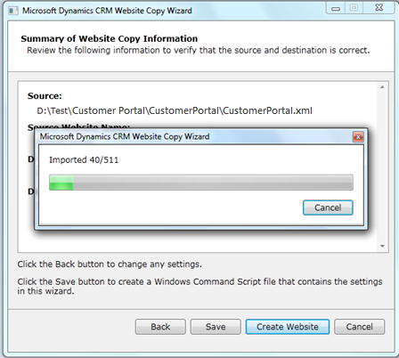
  2. Upon success, the website ‘Customer Portal’ will be listed in CRM in **Content Management** 🡪 **Website** 🡪 **Websites** 🡪 **Active Websites**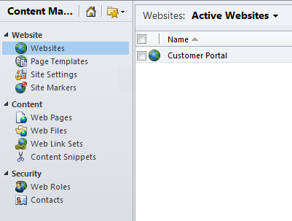

1. Go to the Windows Azure development portal at [http://windows.azure.com/.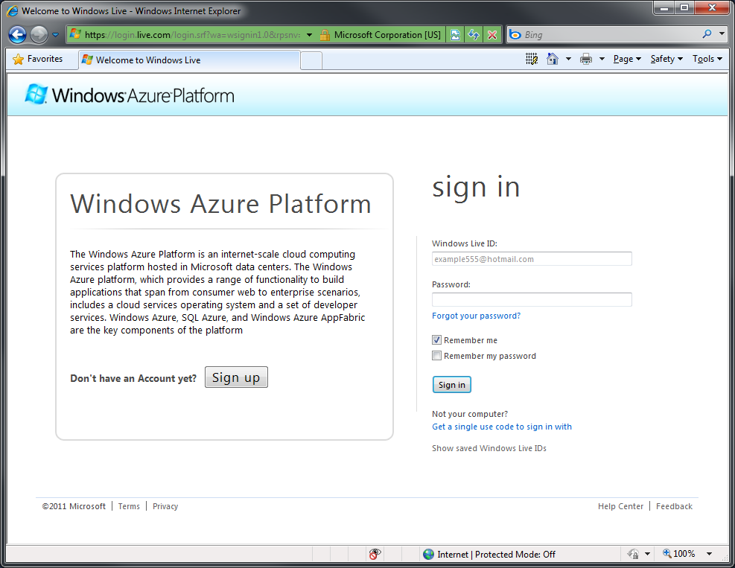](http://windows.azure.com/.)
2. Fill in your Windows Live ID (any WLID account that you would like to use to manage your Windows Live applications can be used) details and then click on **Sign In**.
3. You are now taken to the Azure Management Portal. Click the **New Hosted Service** and **OK** buttons: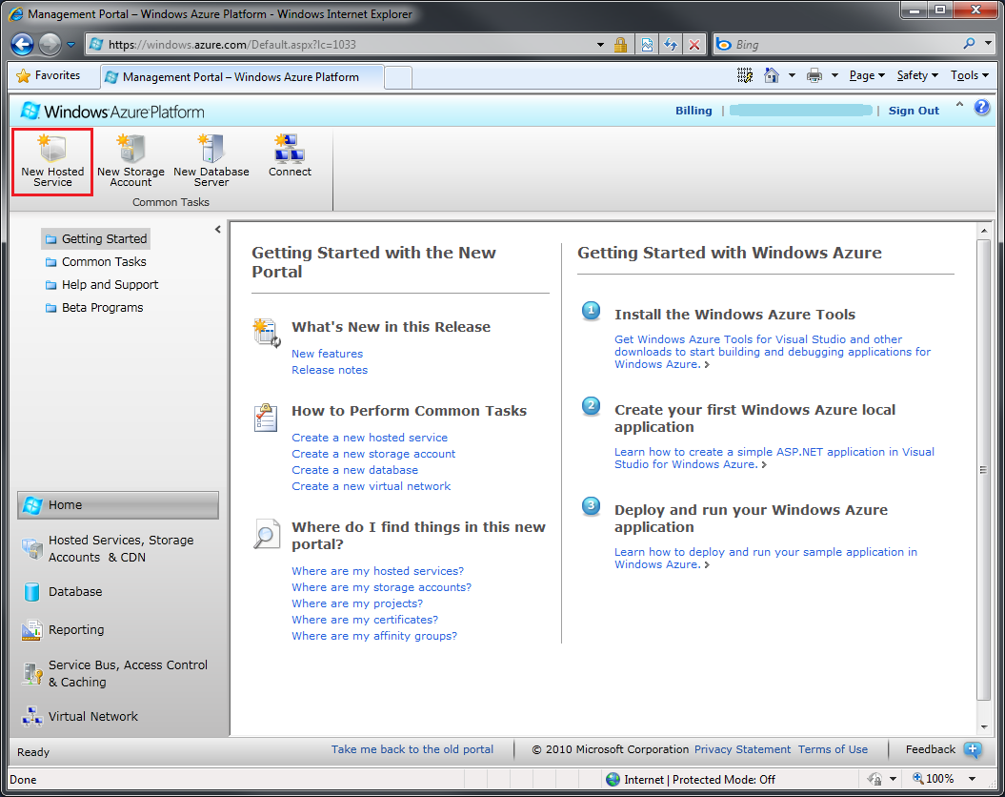
4. Enter a name and URL prefix for the service. This will be the URL where users will access your portal. Select the global region that applies to your organization. Click **Do not deploy**: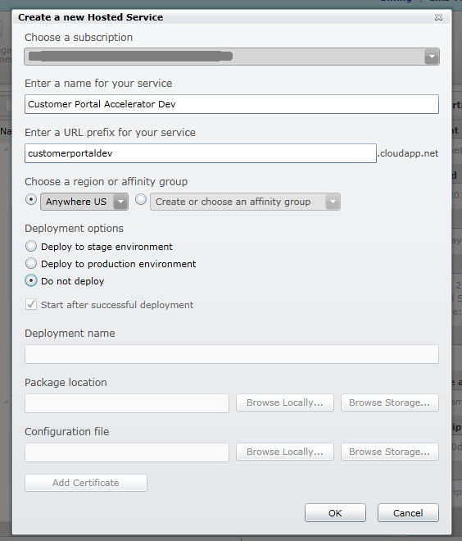
5. Register your application using a Windows Live ID (any WLID account that you would like to use to manage your Windows Live applications can be used). Registering your application allows Windows Live to authenticate with your web portal application. Go to <https://live.azure.com>. Click the **Create Application** link:

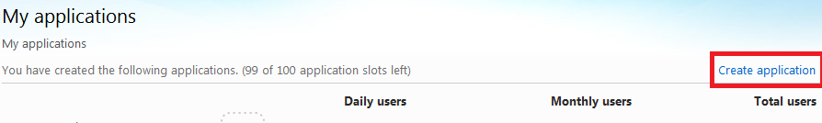

* 1. Specify an application name and choose the language:

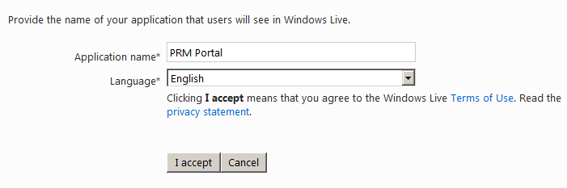

* 1. Click the **I accept** button. This associates the WLID with a Windows Live application developer account.
  2. To complete the registration, click the **Application Settings Page** link.

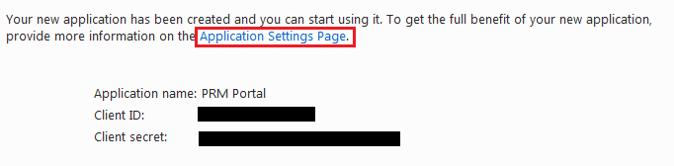

* 1. Specify the URLs that are relevant to your website in the **Settings -> Basic Information** section

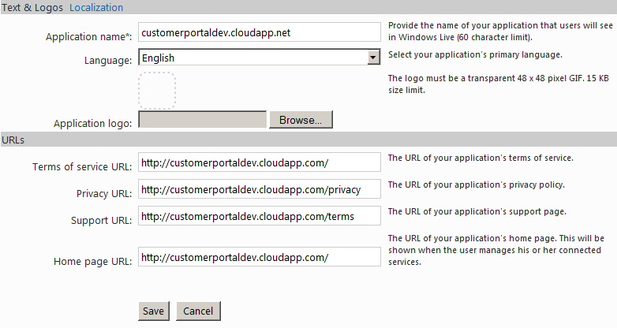

* 1. Click Save and navigate to the **Settings -> API Settings** section

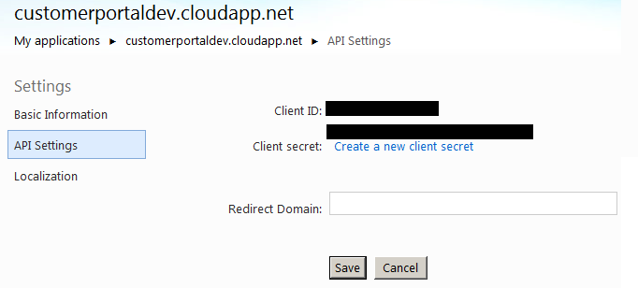

* 1. Make sure that the Return URL specifies the path **/LiveID.axd**.

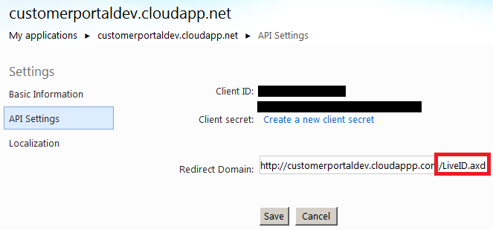

* 1. Complete the remaining forms including: Localization. (Note: blank logo files, in the appropriate sizes, have been included in the portal distribution for your convenience. You can use these, or provide your own.)
  2. Note of the **Client ID** and **Secret Key** values for subsequent configuration.

1. Copy all files and folders from the CustomerPortal folder of your Customer Portal for Microsoft Dynamics CRM setup package to the location on your web server for your portal.
2. Open the Visual Studio solution (CustomerPortal.sln) found in the folder on your web server for your portal. Edit the web.config file to set the connection string properties to connect to your CRM system:
   1. For Microsoft Dynamics CRM Online customers, your connection string will be structured as follows:

<connectionStrings>

<add name="Xrm" connectionString="Url=https://crmurl.crm.dynamics.com; UserName=wlid@hotmail.com; Password=wlidpassword; Device ID=your-device-id; Device Password=your-device-password"/>

<add name="Live" connectionString="Application Id=0000000000000000; Secret=aaaaaaa"/>

</connectionStrings>

1. For Microsoft Dynamics CRM On-Premises customers using Active Directory authentication, the connection string will be structured as follows:

<connectionStrings>

<add name="Xrm" connectionString="Url=http://crm-server-name:port/crm-organization-name; Domain=user-domain; UserName=user-name;

Password=user-password"/>

<add name="Live" connectionString="Application Id=0000000000000000; Secret=aaaaaaa"/>

</connectionStrings>

1. Debug your web project to ensure that the portal will open correctly and get the necessary content from your Microsoft Dynamics CRM system (**Right-click on project 🡪 Debug 🡪 Start New Instance**).
2. Add a new Windows Azure Cloud Service project: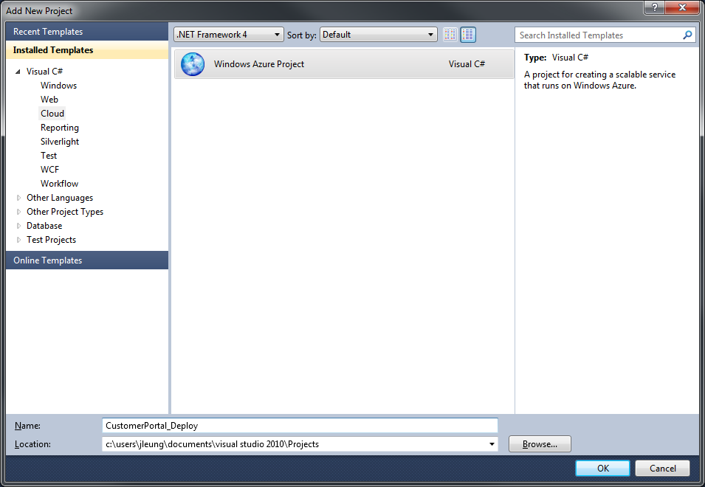

Click OK to continue.

1. Leave the Windows Azure solution list empty. Click the **OK** button: 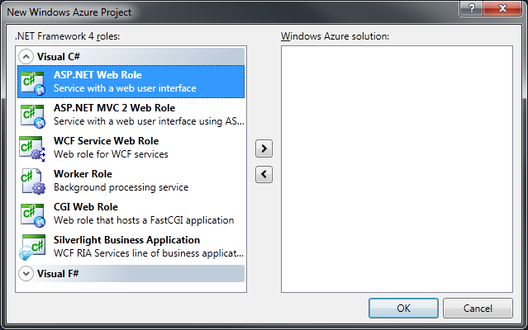
2. Right-click the new Windows Azure Cloud Service project, and then click **Properties**. 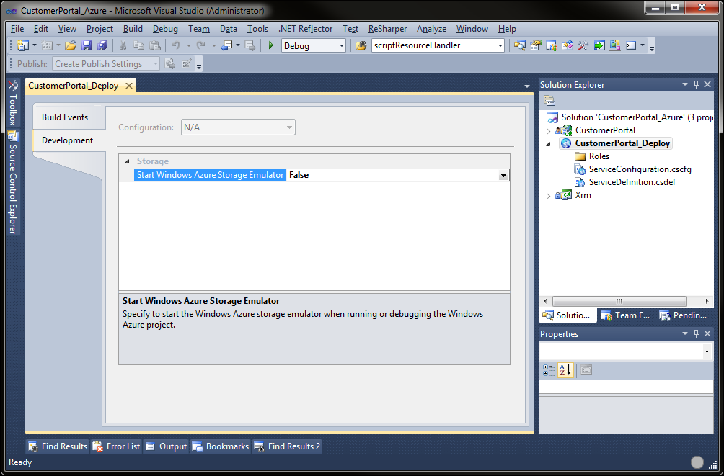

Click the **Development** tab and set **Start Windows Azure Storage Emulator** to **False**. Save this file.

1. Make sure that all microsoft.identitymodel.dll, microsoft.servicebus.dll, microsoft.crm.*.dll, and microsoft.xrm.*.dll references for the project have their Copy Local property set to **True**: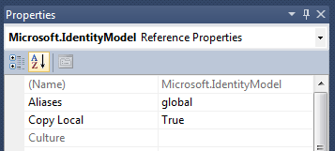
2. Right-click the Roles folder in the Windows Azure Cloud Service project in your solution, click **Add**, and then click the **Web Role Project in solution** option.

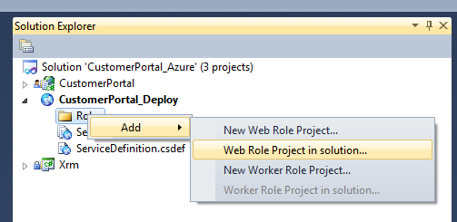

1. Select the project to be the web project in your solution and click OK.

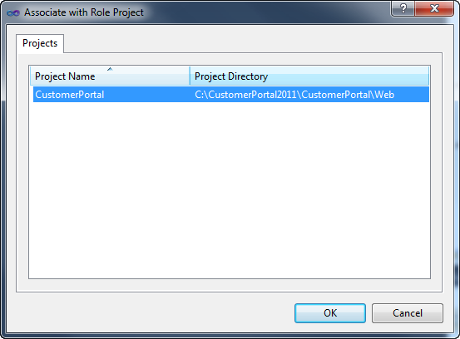

The project will now be associated with the Roles:

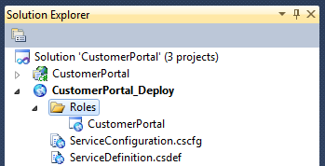

1. Build the entire solution.
2. Right-click the Windows Azure Cloud Service project in your solution, and click **Publish**.
3. Choose Create Service Package Only and click the OK button: 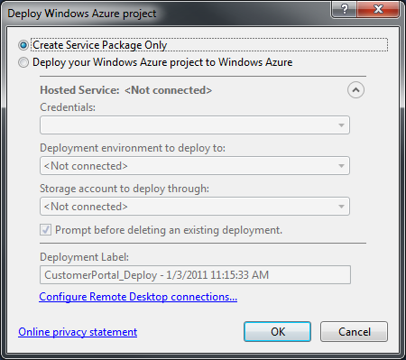
4. This will open Windows Explorer to the location of the service package.
5. Return to the Azure Management Portal. Select the new hosted service, and then click the **New Staging Deployment** button: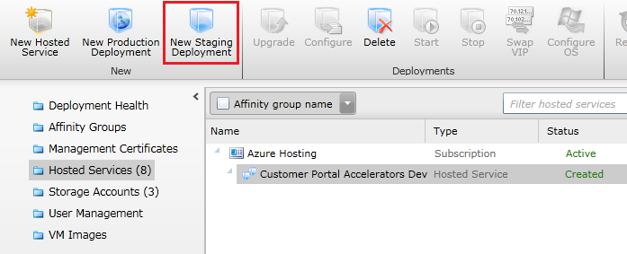
6. Enter a deployment name and select the package location and configuration file for the published service package: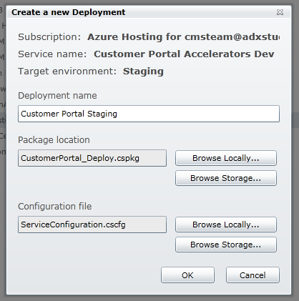   
   Click the **OK** button. A warning may appear indicating that the role contains only one instance. The number of instances can be adjusted (see [Improving Application Availability](http://msdn.microsoft.com/en-us/library/gg236576.aspx)) or the warning can be ignored depending on the availability requirements of the website.
7. When the package is fully uploaded, started, and initialized, the status of the role should indicate **Ready** or **Stopped**. If the status is **Stopped**, start the role by selecting the deployment and clicking the **Start** button:  
   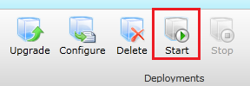
8. Web roles in a staging deployment can be browsed by navigating to the URL: http://<role-ID>.cloudapp.net where <role-ID> is the GUID based ID of the role.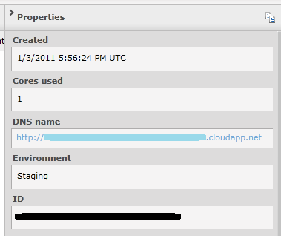  
   The staging deployment can be used to test that the role is hosting and rendering correctly. However, to test Live ID authentication, the role must be running in a production deployment.
9. Select the deployment and click the **Swap VIP** button:  
   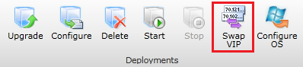
10. Click the **OK** button:  
    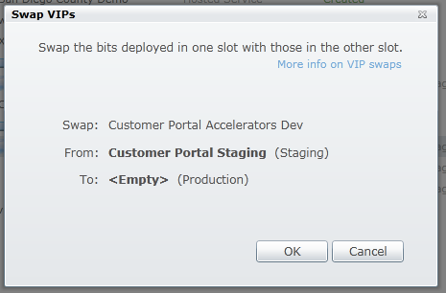  
    After the production deployment is created and started, the role can be viewed at the registered URL displayed under the DNS name field. It is also ready to be verified by Windows Live.
11. Return to <https://live.azure.com>. Click the link to go to the application details and click the **Verify now** link. This time click the **Verify domain** button.  
    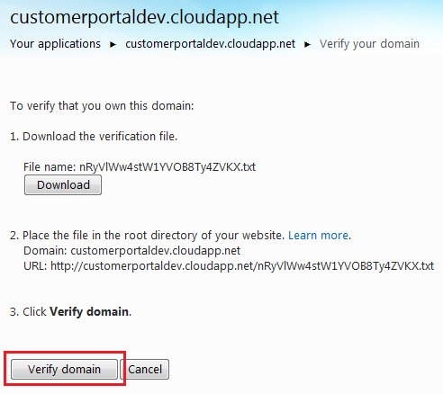
12. With the domain verified, click on the **Application Status** tab.  
    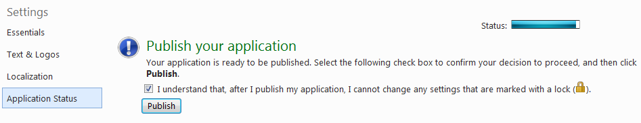Check the checkbox and click the **Publish** button.
13. You are now free to test and configure your new portal!